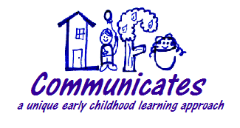
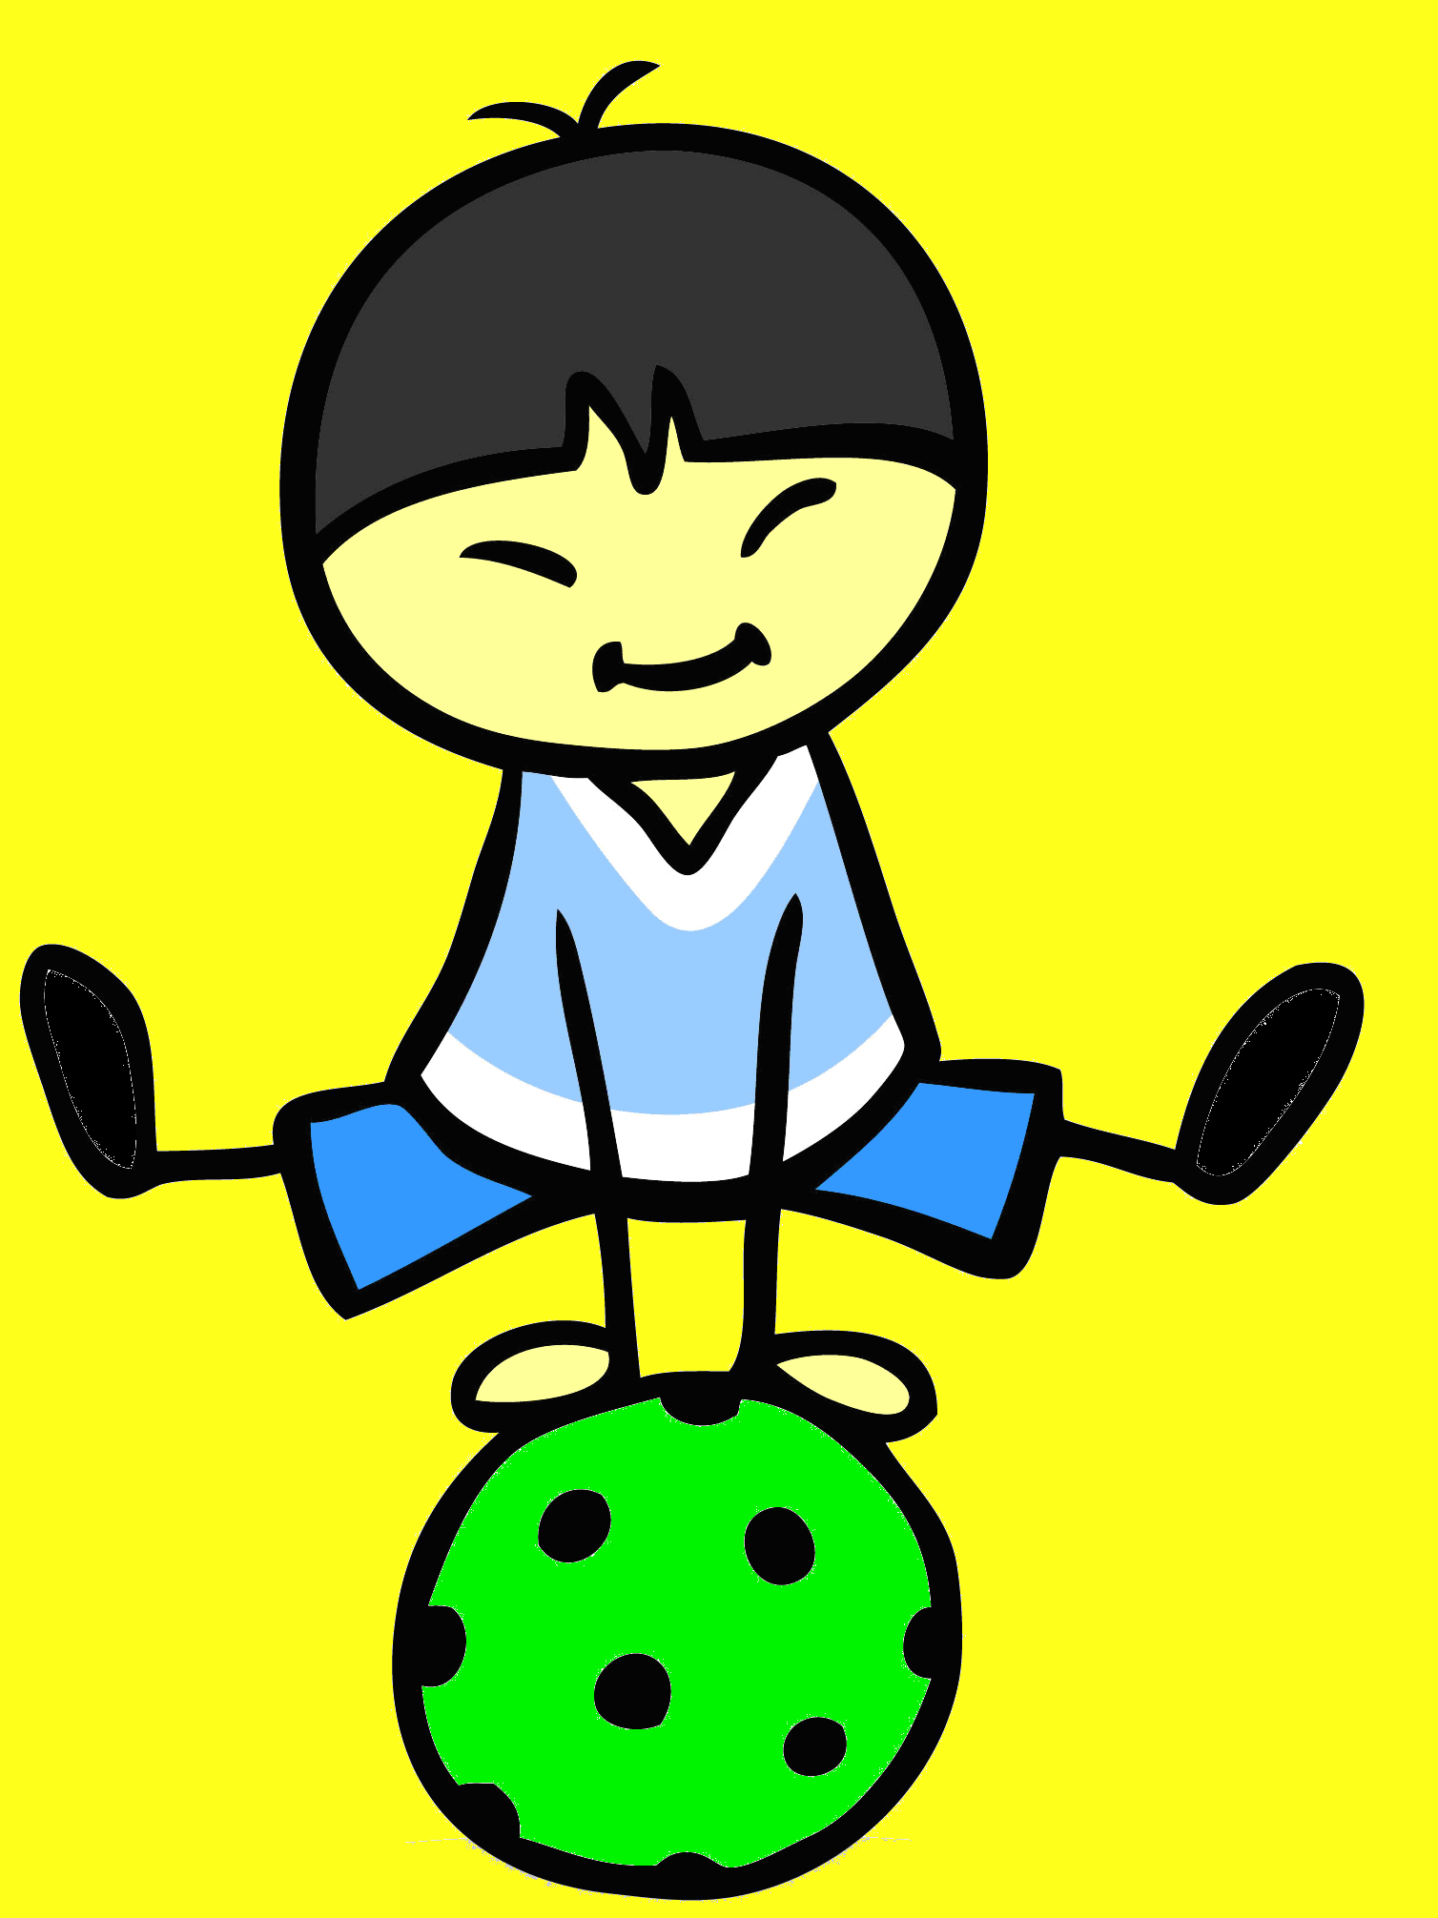
3 - 4 Year Olds
4 - 5 Year Olds
Research shows movement is an essential factor to intellectual growth.

RECEPTIVE & EXPRESSIVE LANGAUGE
- Follows two step directions
- Understands and uses words for family, like brother, grandmother, and aunt
- Understands words for some colors, like red, blue, and green
- Understands and uses words for some shapes, like circle and square
- Understands & uses basic location words
- Understands & names basic opposites
- Understand & can use basic & possessive pronouns (i.e. they, hers, ours, etc.)
- Understands & uses some plural words, like toys, birds, and buses
- Understands & can use past tense, present progressive, articles, etc. in sentences
- Understands & answers who, what, where, how, why, when, how many questions
- Speaks clearly enough to be understood
- Talks about activities at school or at friends' homes.
- Talks about what happened during the day. Uses about 4 sentences at a time.
- Uses a lot of sentences that have 4 or more words.
- Has a vocabulary of approx. 1,000 - 1,600 words

GROSS MOTOR
- Imitates simple bilateral movements of limbs (i.e. arms up together)
- Walks up/down stairs alternating feet
- Jumps in place with two feet together
- Able to walk on tip toes
- Catches using body
- Stands on one foot for up to 5 seconds
- Kicks a ball forwards
- Throws a ball overarm
- Catches a ball that has been bounced

RECEPTIVE & EXPRESSIVE LANGAUGE
- Follows three step directions
- Understands words for order, like first, next, and last.
- Understands words for time, like yesterday, today, and tomorrow.
- Understands & uses more complex pronouns (i.e. herself, yourself)
- Understands & uses more complex verbs in sentences
- Understands & uses more complex location words
- Takes turns talking in conversations
- Answers more types of sentences, but may be confused about more complex sentences
- Hears and understands most of what is said at home and in school.
- Talks in different ways depending on the listener and place
- Has a vocabulary of approx 1,600 – 2,500 words

GROSS MOTOR
- Runs around obstacles
- Able to walk on a line
- Able to hop on one foot
- Jumps over an object and lands with both feet together
- Walks backward toe-heel
- Jumps forward 10 times without falling
- Skips forwards after demonstration
- Steps forward with leg on same side as throwing arm when throwing a ball
- Catches a small ball using hands only

* The skills listed above are skills that we focus on during our lessons, full developmental milestones can be found on www.asha.org (language) & www.apta.org (gross motor).

